Materials and Methods

The model

The model is a sex-instar-age based Leslie matrix model (Caswell 1998). That is, the model is structured such that male crabs have fourteen benthic instars and females eleven benthic instars. Additionally, there are three eggs stages and one pelagic larval stage and categories reflecting individuals in instar-cohorts that have skip molted. The model has a six-month time step and it tracks individual cohorts. The oldest crabs can live is seven years after the terminal molt to instar XIV for males and six years after the terminal molt to instar XI for females. Though life spans will vary depending on skip and terminal molting rates an old and large male crab would be about sixteen years old (measured from time of first benthic instar).

Briefly, Leslie matrix models have a square non-negative parameter matrix (Leslie matrix) whose dimension correspond to the number of sexes, stages and instars, in this case there are 168 different unique potentially positive abundance categories (unique sex-instar-age combinations) hence the effective Leslie matrix is 168*168. On each time step the abundance vector (effective length = 168) is matrix-multiplied with the Leslie matrix and this give a new abundance vector. This process continues to loop for the desired length of the simulation. Various plots and analyses of the time evolution of the population can be constructed the simulation results. This describes the general Leslie model, with fixed parameter matrix throughout the entire simulation, and is what we consider to be the baseline model. The present model, however, can be far more complicated in that the Leslie parameter matrix can be allowed to change on each time step as a function of densities of crabs in different each sex, stage and age and/or random factors related to hypothesised environmental forcing. First we present the baseline model run and then subsequently add fishing effects and alter cannibalism patterns.

The model include several process some of which can be turned off completely, allowed to become dynamic or remain as fixed in the Leslie matrix:

- Cannibalism
- Skip molting
- Terminal molting
- Sperm limitation
- Fishing

A process acts upon one of the 168 unique sex-instar-age combinations though often a process acts identically on a larger subgrouping e.g. an entire instar of males regardless of the time spent at that instar. In the present study we consider cannibalism, skip molting and terminal molting only in the static Leslie matrix sense and we do not consider sperm limitation at all, this is generally a reflection of our knowledge of these processes and the degree of speculation needed to formulate the mechanism of action in the model. Various fishing and cannibalism patterns are considered in scenarios later and we describe these modelled processes in greater detail below.

Cannibalism

Cannibalism (reduction in survivorship) is modelled as a function of predator abundance in the form of an expontially decreasing function, i.e. prey survivorship decreases exponentially as a function of predator abundance. The coefficient of decline in survivorship can be set at the beginning of a simulation thus affecting the strength of cannibalism in the model. There is the option to have seasonal and spatial cannibalistic effects where there is an increased cannibalism factor on some interactions such that larger stages are more effective cannibals. This increased cannibalism is a pseudo-spatial process where some instars at some seasons are more likely to have cannibalistic interactions than others owing to greater spatial overlap. On top of this, there are seasonal effects. Hence there exact level of cannibalism will depend on the particulars of the prey and predator instar pair and season (6 month model). We have however chosen a simpler cannibalism matrix that applies in all time steps. Further scenarios consider other cannibalism scenarios.

Fishing

Fishing can be modelled using a fixed exploitation-rate strategy or a fixed TAC strategy. The former leads to an annually varying TAC that is a function of the abundance of fishable individuals while the later theoretical leads to a fixed catch. With both strategies we assume that fishers have a well defined order of preference for the kinds of crabs they wish to take and also with perfect ability to target them. So if the TAC is 20 tonnes, and the fishable biomass of the most preferred instar-age is 10 tonnes, the second preferred instar 7 tonnes, and the third preferred instar 21 tonnes, then all the fishable biomass of the two most preferred instars will be taken and 3 tonnes of the third most preferred instar taken, thus fulfilling their 20 tonnes TAC. Studies of the fishery captures and landings suggest that this perfect selection model is not far from reality as fisher can achieve this through targeting areas and discarding lesser preferred instars. Additionally, we account for a certain level of fishery induced mortality on instar XII, XIII and XIV softshell crabs. This is a function of the number of large hard shell crabs such that when the latter are abundant softshell fishery induced mortality is decreased as they tend to be more timid and less available to the gear (Ref).

Results

Key run/baseline results

The key run of the model is the baseline run. In this case it includes modelled cannibalism with a simple cannibalism matrix that applies throughout the year. Through trial and error as well as some empirical data on cannibalism patterns (Lovrich and Sainte-Marie 1997), a cannibalism matrix was derived where the most cannibalism on a single instar is from one predator instar but there is extra cannibalism on intars 5, 6 and 7 (Table 1).

Table 1: key run cannibalism matrix, 1 = interaction exists, a blank space indicates there is no interaction
 | I | II | III | IV | V | VI | VII | VIII | IX | X | XI | XII | XIII | XIV | Predator
I |  |  |  |  |  |  |  | 1
II |  |  |  |  |  |  |  |  | 1
III |  |  |  |  |  |  |  |  |  | 1
IV |  |  |  |  |  |  |  |  |  |  | 1
V |  |  |  |  |  |  |  |  |  | 1 | 1 | 1 | 1
VI |  |  |  |  |  |  |  |  |  |  | 1 | 1 | 1 | 1
VII |  |  |  |  |  |  |  |  |  |  |  | 1 | 1 | 1
VIII
IX
X
XI
XII
XIII
XIV
Prey

Other other matrices were tried, some producing cycles while other running to a constant steady state.

The key run produces a classic cycling population, here depicted the the terminally molted males only, with a period of 10.8 years and peak to trough abundance ratio of 5.8. Other cannibalism matrices can produce periods of between 9 and 16 years but most of these require tenuous cannibalism assumptions. What does appear to be true is that cannibalism that is too diffuse tends to dampen out cycles. There is also an suggestion that diffusing the cannibalism tends to shorten the cycle period but the effect are usually more black and white, i.e. it is difficult to produce a continuous range of cycle periods, simply by altering the cannibalism matrix and certain periods seem common while others not.

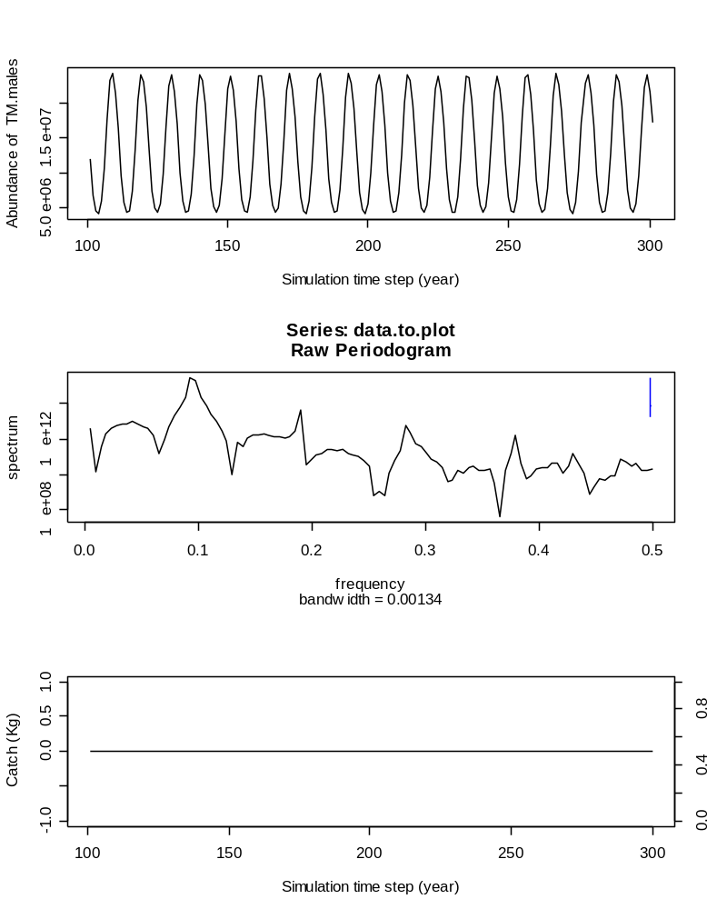
Figure 1: key run results for terminally molted males and cannibalism matrix of Table 1. Peaks in the power spectrum (second panel) indicate dominant frequencies (1/year), e.g. the largest peak at 0.1 indicates that the dominant cycle period is 10 years.

Key run with fishing

Fishing is parameterised in the model with either a fixed exploitation-rate strategy or a fixed TAC strategy. Various instars and conditions are targeted with different preferences such that they are fished sequentially in order of preference until the set TAC is fulfilled or the TAC deriving from a fixed exploitation-rate strategy (Table 2). For the fixed TAC strategy, if the TAC is larger than the fishable biomass of legal crabs, then the TAC is reduced accordingly. Regardless of the fishing strategy, there is a limit on the maximum amount of any instar-condition combination that can be fished, this has been set at 80% but can be altered. This unfishable biomass is a reflection of inability of the fishery to take 100% of the biomass of crabs even if they are legal size and could conceivably arise owing to unfishable areas, limited seasons or closures marine protected areas etc.

Table 2: Preference order for instar and condition for commercial fishing. Only 50% of the individuals in instar XII are considered to be over the legal carapace width size of 95 mm
Instar | Condition | Carapace width (mm) | Fishery Preference
XII | not TM | 96.7 | 14
 | 2 | 96.7 | 6
 | 3 | 96.7 | 3
 | 4 | 96.7 | 9
 | 5 | 96.7 | 12
XIII | not TM | 115 | 13
 | 2 | 115 | 5
 | 3 | 115 | 2
 | 4 | 115 | 8
 | 5 | 115 | 11
XIV | 2 | 136 | 4
 | 3 | 136 | 1
 | 4 | 136 | 7
 | 5 | 136 | 10

Fixed exploitation-rate strategy

The fixed exploitation-rate strategy produces cycles with a 10 year period as in the key run. Fishing strategy or intensity has very little ability to change the cycle period and that is mostly a function of the chosen cannibalism matrix. Fixed exploitation-rate strategies therefore means that catch follows peaks and troughs in population abundance with a peak/trough ratio of 5.8 (Fig. 2). A high exploitation-rate strategy show practically the same pattern though the peak/trough ratio is 5.85 (Fig. 3); however, the high exploitation-rate strategy consistently gives high catches for the comparable places in the cycle as the low exploitation-rate strategy. This say nothing, however, of the amount of effort it would require to carry out these two strategies.
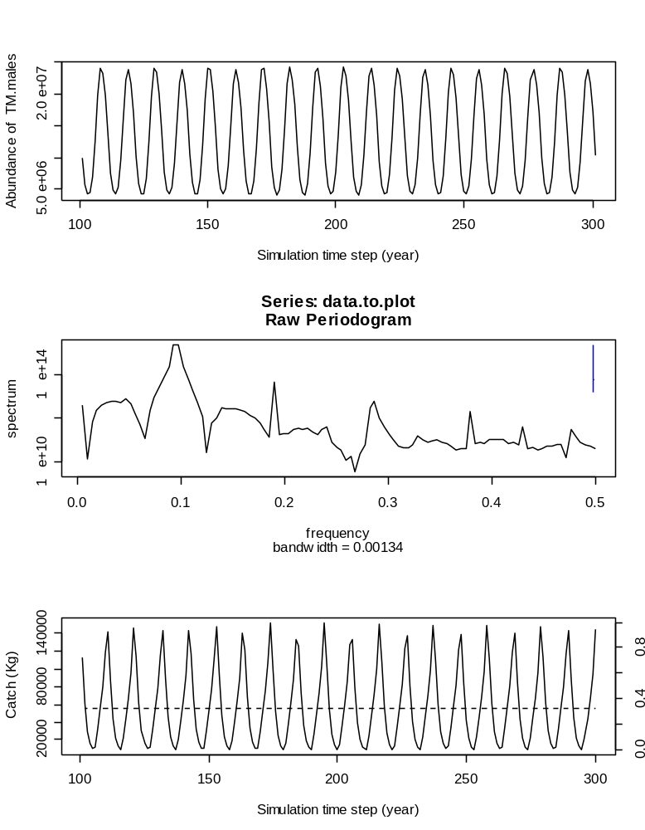
Figure 2: low fixed exploitation-rate strategy (40% of legal population instars 12 and larger, >95 mm). The dotted line on lower panel and right y-axis is the realised exploitation-rate. Only 50% of Instar 12 is over the legal size limit of 95 mm. There is a fishery inefficiency of 20%, thus the realised exploitation-rate is 32%. Peaks in the power spectrum (second panel) indicate dominant frequencies (1/year), e.g. the largest peak at 0.1 indicates that the dominant cycle period is 10 years.

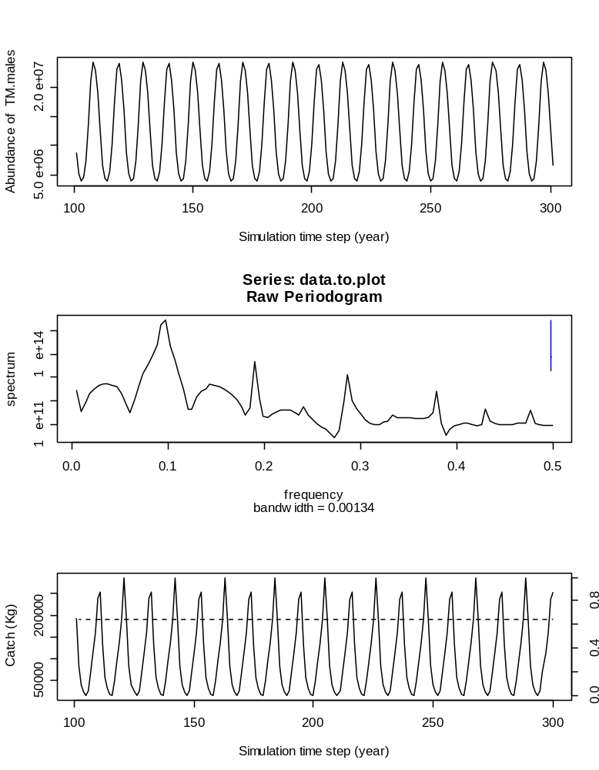
Figure 3: high fixed exploitation-rate strategy (80% of legal population instars 12 and larger, >95 mm). The dotted line on lower panel and right y-axis is the realised exploitation-rate. Only 50% of Instar 12 is over the legal size limit of 95 mm. There is a fishery inefficiency of 20%, thus the realised exploitation-rate is 64%. Peaks in the power spectrum (second panel) indicate dominant frequencies (1/year), e.g. the largest peak at 0.1 indicates that the dominant cycle period is 10 years.

Fixed TAC strategy

A fixed TAC strategy is aligned with how snow crab fisheries are presently managed. The low TAC strategy gives a constant low catch with a exploitation-rate between about 5% and 45% that varies with population abundance (Fig. 4). The high exploitation-rate strategy does not give a constant catch but instead catch plateaus at the set TAC but will decline as population abundance declines (Fig. 5). This results in an exploitation-rate that varies between 20 and 80%. Note that because of the fishing refuge of 20%, the maximum exploitation-rate can only be 80%. Again, the fishing effort required to achieve these catches might be impossibly large.
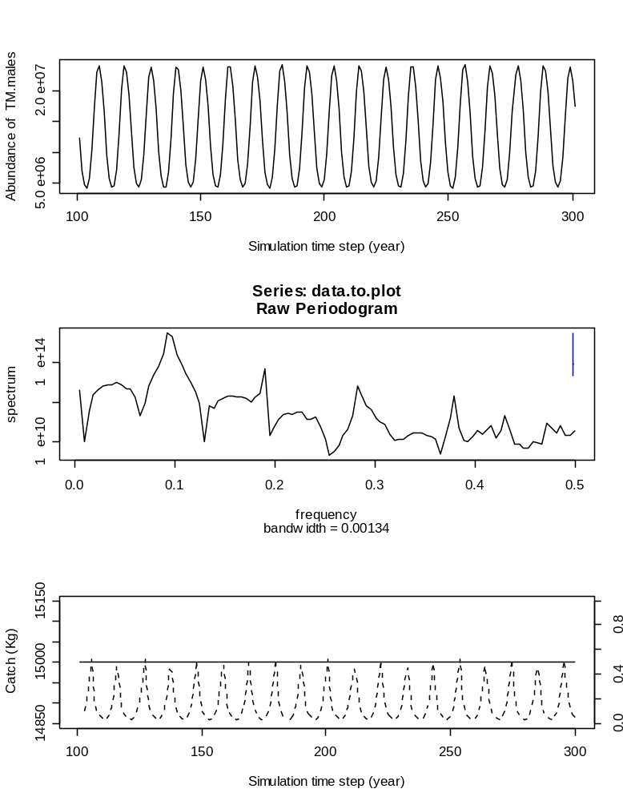
Figure 4: fixed TAC with low TAC (15,000 kg), exploitation-rate is the dotted line in lower panel with second y-axis. Peaks in the power spectrum (second panel) indicate dominant frequencies (1/year), e.g. the largest peak at 0.1 indicates that the dominant cycle period is 10 years.

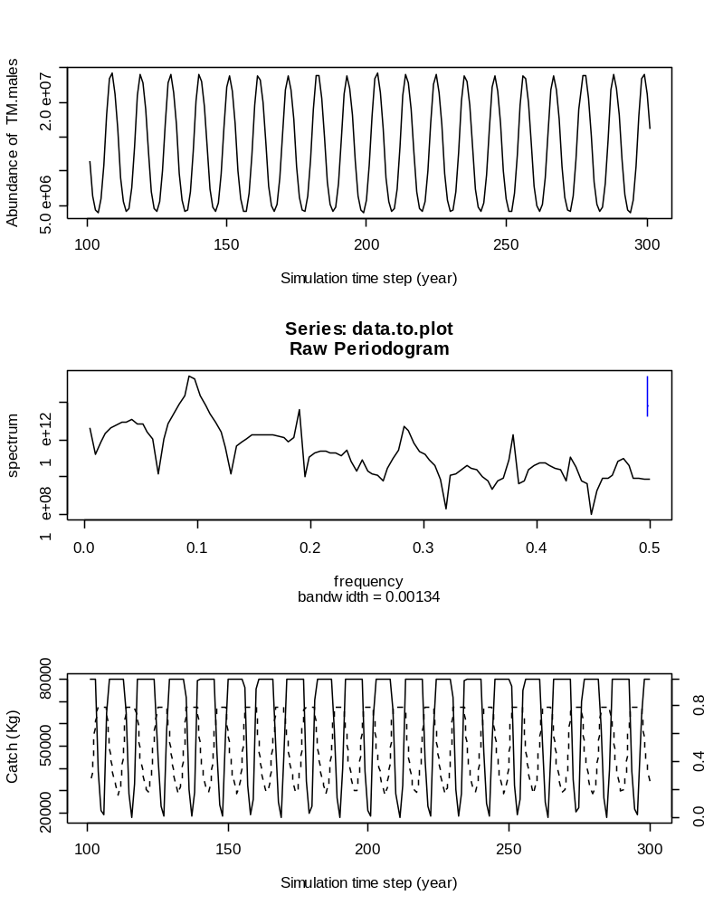
Figure 5: fixed TAC with high TAC (80,000 kg), exploitation-rate is the dotted line in lower panel with second y-axis. Peaks in the power spectrum (second panel) indicate dominant frequencies (1/year), e.g. the largest peak at 0.1 indicates that the dominant cycle period is 10 years.

Alternate cannibalism scenarios

The alternate cannibalism scenario of competition mortality was considered. That is, that the immediate pre-recruit instars (9, 10, 11) had encounters with larger instars and suffered mortality as a result. This scenario yielded a constant steady state result with no cycles (not shown here).

A second cannibalism matrix was then used that included both the key run cannibalism and the competition mortality cannibalism as above. This produced very interesting population results, with strong cycles of several periods appearing in the population (Fig. 6). The dominant period was 3.5 years though, there are also strong cycles with periods of about 6-8 years and 2.2 years. The maximum peak/trough ratio is 10.7 but is considerably less for most periods as the troughs all seem to be to about the same population abundance while the peaks are quite variable.

When this combined cannibalism, competition matrix was subjected to fishing, again there was little change in the periodicity. The only factor that did change was the maximum peak/trough ratio which was 11.6.

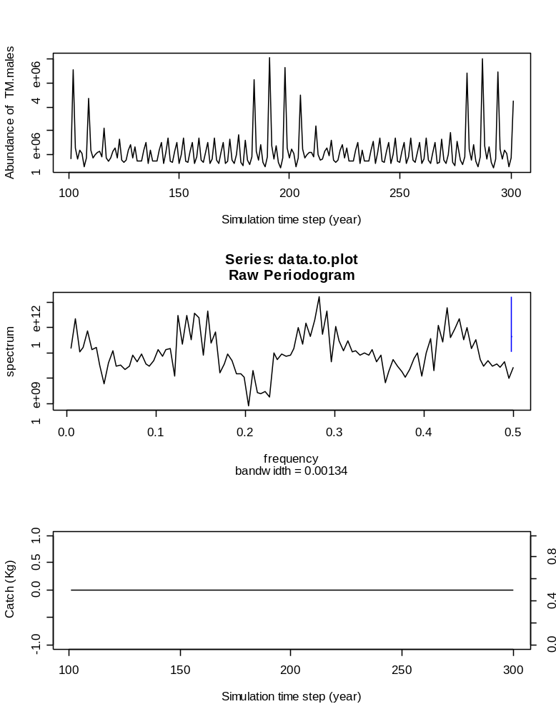
Figure 6: results for terminally molted males and cannibalism matrix of Table 1 combined with fatal interfence competition by large crabs on immediate pre-recruits. Peaks in the power spectrum (second panel) indicate dominant frequencies (1/year).

Summary of results

- Cycle period is about 10 years in key run
- Cycle period is far more complex when key run is combined with fatal interference competition between large instars
- Period is very sensitive to cannibalism and practically insensitive to fishing
- Fixed TAC strategy will allow constant catches only at low to moderate TAC but at high TAC catches will fluctuate considerably
- High TAC or exploitation-rate strategies allow the highest catches overall

Speculations on results

The fact that cannibalism but not fishing affects the cycle period suggests that cycles arise from mortality occurring in pre-recruit sizes. Once crabs have recruited to the fishery, cycles have already been established. It also suggests that the primary cause of cycles arises in the pre-recruit sizes and is forced mostly by pre-recruit predators. This is all to say that unless fisheries start targeting very small crabs (instars 7-10), then it is unlikely that fisheries can have much influence on population cycles. Fatal competitive interactions between recruited and immediate prerecruit instars does add considerable complexity to the kind of cyclicity that occurs. Still, even strong fisheries don’t seem able to affect the cyclicity.

Caswell, H. 1998. Matrix population models. Sinauer Associates.
Lovrich, G.A., and Sainte-Marie, B. 1997. Cannibalism in the snow crab, Chionoecetes opilio, and its potential importance to recruitment. Journal of Experimental marine Biology and Ecology. 211.

